**FUTURE TENSE**

1. Watch the video called: **Tomorrowland**.

i. watch the segment and make a list of all the things that you managed to see that the director believes are going to be common in the future.

ex: -there will be flying cars.

-people will use holograms

write at least three sentences:

1.

2.

3.

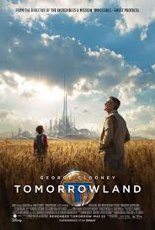

II. Design the ideal world for the future. Imagine that there are no limits to what you can do, Then share your "new world" with the class. Be creative!

Write 5 sentences with the structure given in the example:

Example: People **will travel** to the space for holidays

1.

2.

3.

4.

5.

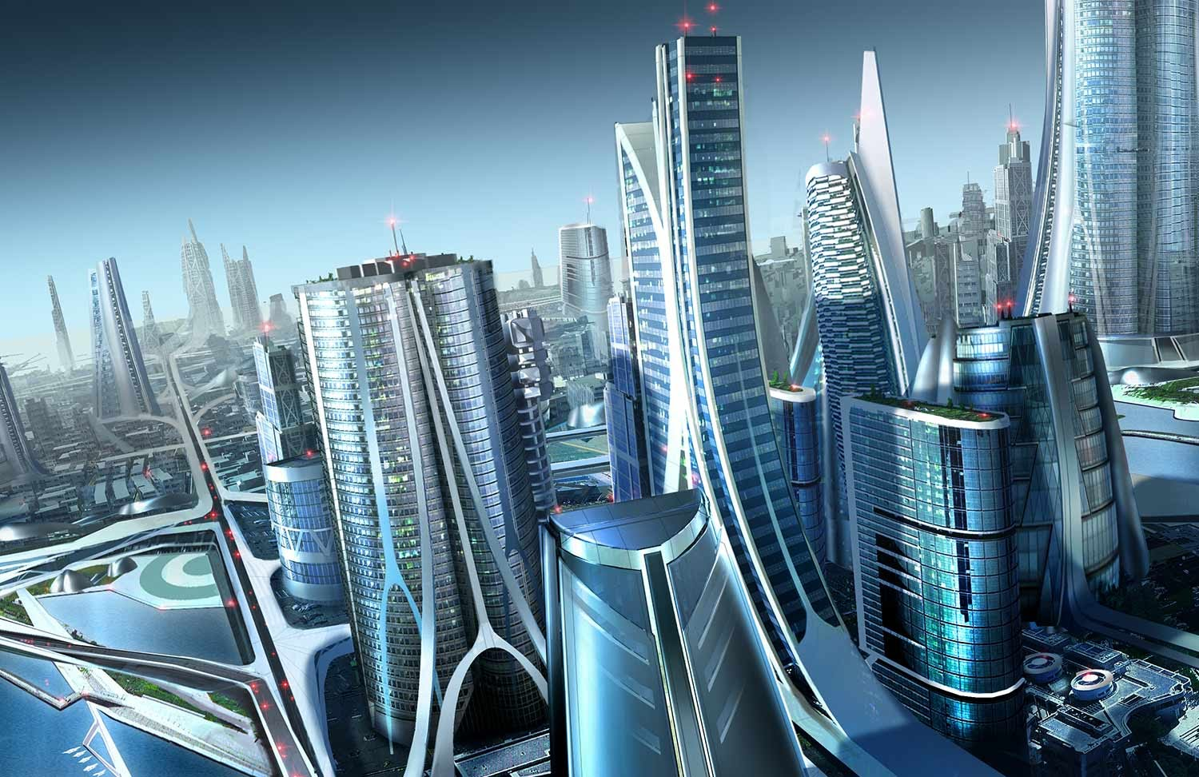

|  |
| --- |
| **Rude (Magic)**  A. Complete with PAST SIMPLE  Saturday morning __________ out of bed And ______________ on my best suit I _________ in my car and __________ like a jet All the way to you I ________________ on your door with heart in my hand To ask you a question 'Cause I know that you're an old-fashioned man, yeah  B. Listen and complete with FUTURE forms, it is a complete sentence, some may use contractions.  ***CHORUS***  *Can I have your daughter for the rest of my life? Say yes, say yes 'cause I need to know You say I ______________ your blessing 'til the day I die Tough luck, my friend, but the answer is 'No'  Why you gotta be so rude?  Don't you know I'm human too? Why you gotta be so rude? I ________________________ her anyway  Marry that girl - Marry her anyway Marry that girl - Yeah, no matter what you say Marry that girl And we _________________ a family Why you gotta be so rude………..?*  I hate to do this, you leave no choice I can't live without her Love me or hate me, we _______________ boys Standing at that altar Or we __________________ away To another galaxy, you know You know she's in love with me She __________________ anywhere I go  **REPEAT *CHORUS*** |